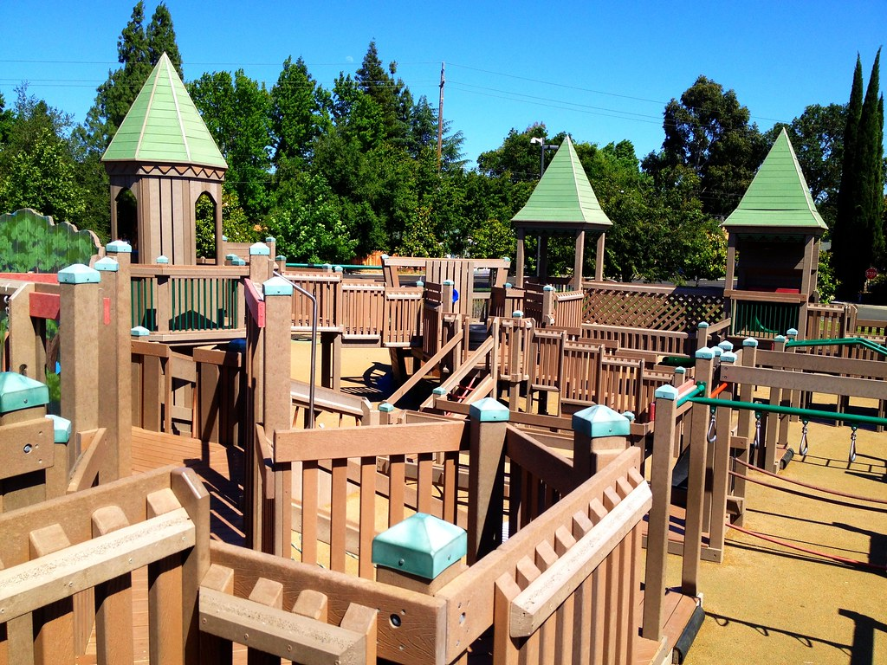
This Photo by Unknown Author is licensed under CC BY

Volunteer sign-up for the Playground of Dreams Sealing Project
Friday, September 15, 2023
Saturday, September 16, 2023

I would like to volunteer for: (please check the days you are volunteering for)

_____ Friday, September 15th

____ Saturday, September 16th

First Name: ___________________________________________

Last Name: ___________________________________________

Phone number: ________________________________________

Email: _______________________________________________

Address: ______________________________________________

Waivers signed ____

